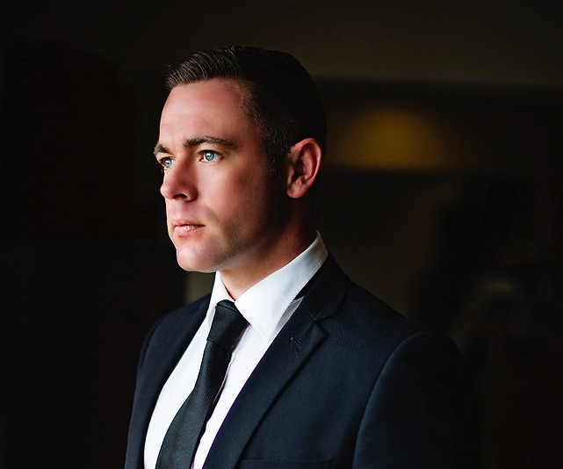
EUGENE OELOFSE

PROFESSIONAL PROFILE

Highly accomplished, results driven Marketing & Communications Specialist with 13 years plus experience. Brand oriented professional with a proven track record of creating incremental revenue utilizing varied communications strategies and Internet technologies to Package and sell products and services.

Entrepreneurial achiever with extensive skills and experience, marketing both domestically and internationally. Strong leader with proven ability to interact with all levels of management and the organization. Solid reputation for creating new high-value revenue streams complemented by outstanding skills in communication and presentation. A self-starter, with a strong commitment to implementing cost effective solutions and a track record of generating excellent returns and effective CREATIVE campaigns.

PERSONAL DETAILS

Nationality South African
Languages English, Afrikaans
Dependents None
Drivers License International Passenger Vehicle
Notice period 30 Days
Criminal Record None
Health Excellent
Marital Status Single
Mobile +66 (0) 92 267 9275
E-Mail eugeneoelofse@aol.com
Skype eugenecr
Blog eugene.oelofse@wordpress.com

EDUCATION

IMM Graduate School of Business Honors Marketing Management 2016
IMM Graduate School of Business Postgraduate Marketing Management 2013
UNISA Management, Economics, Accounting 2010
University of Cape Town - GSB Strategic Brand Management 2007
PE Technikon Graphic Design National Diploma 2002
Port Rex High School Matriculated 1999

INDUSTRY OVERIEW

- Hospitality and Property Development – 8 years
- Advertising and Communications – 5 years

SKILLS

- CRM - Advanced
- Communications - Advanced
- Marketing – Advanced
- Digital - Advanced

SOFTWARE

- Adobe CS – Advanced
- MS Office – Advanced

CAREER OVERVIEW

AKARYN Hotel Group 2014 - 2016
Branding and Communications Director

A Collection of Boutique Luxury Hotels and Resorts located within Thailand and Beyond

- Increased Retention and Direct booking through Online strategies
- Increased Direct Web traffic by 300%
- Developed a CRM Program, activated both at corporate and property level
- Developed a Consumer engagement Program
- Delivered the largest growth to the SLH Club platform
- Successfully opened akyra Manor Chiang Mai
- Successfully developed Resort and Hotel strategies for Arovada and the President
- Developed the Brand hierarchy, statement, personality and positioning
- Managed all external agencies and drive the key strategies and performance thereof
- Developed and Implemented a fully integrated marketing plan to achieve growth and exceed the business objectives.
- Delivered and achieved key international communications objectives through the Implementation of creative campaigns.
- Introduced new Marketing Mechanics to enhance the Marketing of the Group

Premier Hotel & Resorts Group 2012 - 2014
Group Marketing Manager

A Mixed Portfolio of 3/4/5 star Business Hotels and Luxury Resorts Located in South Africa

- Developed a successful loyalty program
- Developed the Brand Structure of the Group
- Developed and managed the yearly Corporate Communications strategy
- Set, implemented and managed the annual budgets ensuring an effective R.O.I.
- Introduced new marketing mechanisms to allow for brand equity goals to be achieved
- Set and developed the Annual Marketing Strategy
- Opened 3 new Hotels under the Premier umbrella
- Developed an effective consumer engagement program

PUNCH FACTORY 2010 – 2012
Brand Director

Brand Specialist Agency focused on Lifestyle Hotel & Residential developments as well as Consumer Brands.
Clients: Audi SA, Brandhouse, Wakari Lifestlye Estate, kreat, Hemingways Retail Mall, Sinati Golf Estate.

- Brand Planning, Creative Development and Implementation
- Product Development & Market Research
- Developed Above and Below the line campaigns
- Brand Positioning within consumer markets and aligned communications thereof
- Research, Managed & Developed all media channels

MURVALE PRIVATE EQUITY 2006 - 2010
Marketing Manager

A European based Private Equity firm focused on Lifestyle housing developments in South Africa

- Marketing Strategy Development
- Developed and Managed all Media Channels
- Brand Positioning within the immediate European market thereafter the secondary SA market
- Brand Messaging and Development of all USP’s
- Developed all visual Communications
- Developed On-Line Strategy
- Market Analysis & Reporting

DI-STAP COMMUNICATIONS 2004 - 2006
Creative Director

Communications Agency, specializing in Golfing, Lifestyle Developments and Government

• Creative Director of all visual communications for select brands.
• Campaign Development and channel management of all media.
• Developed and Successfully managed the Creative Team.

GRAFIXATION 2002 – 2004
Creative Director

Advertising Agency focused on Retail and various SMME’s

- Opened and Developed the Second Largest Advertising Agency in the Eastern Cape.
- Development, Implementation and Conceptualization of various Fully Integrated campaigns.
- Developed and Successfully managed the Creative Team.

OTHER EMPLOYMENT

- First employment at the age of 9 as a ball boy for the Provincial Rugby Team and the 1995 Rugby World Cup.
- Paper routes through my local area.
- Sales Person at Surfsation Surf Shop.
- Barmen at Buccaneers Pub and Night Club

INTERESTS

Socializing, Travel, Tri Athlon, Surfing, Cooking, Fine Dining, Tennis

REFERENCES

Anchalika Kijkanakorn
Company: AKARYN Hotel group
Designation: CEO
Contact Numbers: +66 81 854 3808
E-mail: anchalika@ahmshotels.com

Name: Richard Bray Name: Marcel Beoni
Company: Premier Hotels & Resorts Company: AHMS – The Collection
Designation: Operations Director Designation: Director of Sales and Marketing
Contact Numbers: +27 (0) 79 399 1049 Contact Numbers: +66 0 81 808 4646
E-Mail: richard.b@premierhotels.co.za E-Mail: marcel.boeni@go-vacation.com

Name: Diane Stap Name: Adrian Murphy
Company: Di-Stap Communications Company: Murvale Private Equity
Designation: Director Designation: Director
Contact Numbers: +27 0 83 659 8919 Contact Numbers: +353 877 457 220
E-Mail: di@di-stap.com E-Mail: adrianmurphymail@gmail.com

